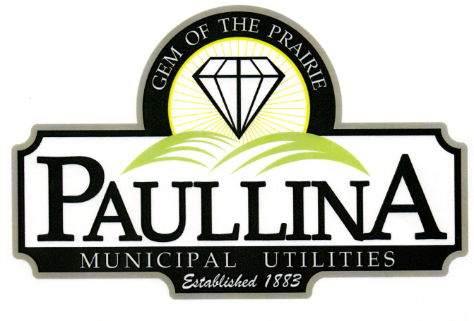

City of Paullina

TENTATIVE REGULAR CITY COUNCIL MEETING AGENDA

Monday, August 17th, 2026, at 5:30pm

Location: City Hall Council Chambers, 127 South Main St, Paullina, IA 51046

- Call to order - Roll Call - Pledge of Allegiance
- Approval of agenda
- Public Forum* for items on and off the agenda
- City Announcements:
- Consent Agenda (All consent items will be enacted by one motion. There will be no separate discussion of these items unless a request is made prior to the time Council votes on the motion.)
  - Minutes:
    - Approve minutes from 08-03-2026 Regular City Council Meeting
  - Financials:
    - Approve Claims
    - Approve Revenues
    - Receive July Financials
    - Receive the Outstanding Debt Report
  - Council Meeting
    - Approve moving the next City Council meeting to Tuesday, September 8th, due to the Labor Day Holiday
  - Fire Department
    - Approve Paullina Volunteer Fire Department applicant.
- FY-27 Budget
  - Public Hearing for FY-27 Budget Amendment
  - Approve Resolution No. 2026-42 Adopting the FY-27 Budget Amendment
- Water Rates
  - Public Hearing for proposed new water rates.
  - Approve Resolution No. 2026-43 to amend ordinance pertaining to water rates.
  - First reading for water rate ordinance amendment
  - Motion to wave 2nd and 3rd reading
- Paullina Bike Path
  - Motion to approve a Resolution Setting Notice of Time and Place of Public Hearing on Proposed Acceptance of Real Estate by Gift from First Cooperative Association d/b/a AgState
- 105 N Main St
  - Motion to extend the bid deadline for 105 N Main St to September 30, 2026
- Airport
  - Motion to approve appointment of Airport Zoning Administrator
  - Motion to approve the appointment of two members to the Airport Board of Adjustment, for two-year and four-year terms, respectively
- Murphy Tractor and Equipment
  - Motion to approve line of credit through Murphy Tractor and Supply
- Reports
  - Superintendent of Utilities and City Clerk Reports
  - Mayor and City Council Comments
  - Committee Reports
  - Departments – Police/Fire/Ambulance/Library/Airport

- Adjourn
REMINDERS: Next City Council meeting Tuesday, September 8th, 2026 at 5:30 pm

*Public Forum is the City Council’s opportunity to hear comments from City residents at the beginning of the Regular City Council Meeting for items both on and off the agenda, except for “public hearing” items. During Public Forum, the City Council receives comments and refrains from speaking. The Mayor may ask the City Clerk or a Council Member to follow up. The number of speakers will not usually be limited at the public forum; total length of the forum is desired to not exceed fifteen (15) minutes, and may be lengthened at the discretion of the Mayor and Council. Anyone who wants to speak during Public Forum should do the following:
1. Raise your hand to be recognized by the Mayor and then stand and state your name and address. If you have handouts, please give them to the City Clerk before the meeting.
2. Be concise and limit comments to five (5) minutes. You may not save your time for later or yield the remainder of your time to someone else. After speaking, please be seated.
3. If you are addressing a matter on the agenda, state the agenda item you are speaking about and if you are speaking on more than one agenda item, arrange your comments in chronological order.
4. Try not to duplicate information that has already been presented.
5. Direct comments to the entire Council and not to an individual. Questions and issues raised during this time will generally not be answered during this time.
6. Maintain a courteous and respectful manner.
7. If you are the presenter on an item which has been formally placed on the Council agenda, this public forum process does not apply, although you are asked to be succinct in your presentation.
8. Iowa law requires certain matters to have public hearings, which have their own comment periods. Comments pertaining to a public hearing item should be saved for that item, and the five-minute comment period will also apply for public hearings.
Thank you to everyone in the audience for attending this important business meeting.

