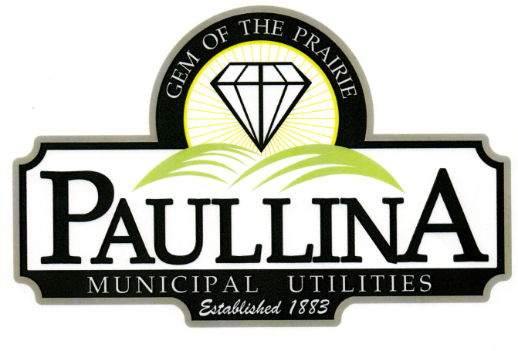

City of Paullina

TENTATIVE REGULAR CITY COUNCIL MEETING AGENDA

Monday, June 15th, 2026, at 5:30pm

Location: City Hall Council Chambers, 127 South Main St, Paullina, IA 51046

- Call to order - Roll Call - Pledge of Allegiance
- Approval of agenda
- Public Forum* for items on and off the agenda
- City Announcements:
- Consent Agenda (All consent items will be enacted by one motion. There will be no separate discussion of these items unless a request is made prior to the time Council votes on the motion.)
  - Minutes:
    - Approve minutes from 06-01-2026 Regular City Council Meeting
  - Financials:
    - Approve Claims
    - Approve Revenues
    - Approve Resolution No. 2026-29 end of Fiscal Year Transfers
  - License:
    - Approve The Chamber of Commerce Liquor License 0-010-800-776
  - Vector:
    - Approve Resolution No. 2026-30 Approving Vector Rep and Alternate

- O’Brien County Economic Development
  - Kianna Johnson will give annual update

- DGR
  - Logan Smidt will be present to update the Council on Paullina’s water system

- MidAmerican
  - John Huff and Project Developer Alex Behnke will be present to update the Council on MidAmerican Energy Highland Repowering Project Update.

- Street Maintenance
  - Review bids
  - Motion to approve Beck Excavating bid
  - Motion to approve Black Top Services bid

- Renewable Energy Credits
  - Motion to approve Resolution No. 2026-30 approving the REC Contract

- Street Closures
  - Motion to approve Resolution No. 2026-31 to close streets in the business district for the grand opening of Paullina Bicycle Co.

- Police Department
  - Motion to approve the purchase of a new police vehicle

- Electric Rates
  - Second reading for electric rate ordinance amendment
  - Motion to waive 3rd reading

- DOT Contract
  - Motion to approve Resolution No. 2026-31 approving DOT Agreement for Maintenance and Repair of Primary Roads in Municipalities

- Reports
  - Superintendent of Utilities and City Clerk Reports
  - Mayor and City Council Comments
  - Committee Reports
  - Departments – Police/Fire/Ambulance/Library/Airport

- Adjourn
REMINDERS: Next City Council meeting July 6th, 2026 at 5:30 pm

*Public Forum is the City Council’s opportunity to hear comments from City residents at the beginning of the Regular City Council Meeting for items both on and off the agenda, except for “public hearing” items. During Public Forum, the City Council receives comments and refrains from speaking. The Mayor may ask the City Clerk or a Council Member to follow up. The number of speakers will not usually be limited at the public forum; total length of the forum is desired to not exceed fifteen (15) minutes, and may be lengthened at the discretion of the Mayor and Council. Anyone who wants to speak during Public Forum should do the following:
1. Raise your hand to be recognized by the Mayor and then stand and state your name and address. If you have handouts, please give them to the City Clerk before the meeting.
2. Be concise and limit comments to five (5) minutes. You may not save your time for later or yield the remainder of your time to someone else. After speaking, please be seated.
3. If you are addressing a matter on the agenda, state the agenda item you are speaking about and if you are speaking on more than one agenda item, arrange your comments in chronological order.
4. Try not to duplicate information that has already been presented.
5. Direct comments to the entire Council and not to an individual. Questions and issues raised during this time will generally not be answered during this time.
6. Maintain a courteous and respectful manner.
7. If you are the presenter on an item which has been formally placed on the Council agenda, this public forum process does not apply, although you are asked to be succinct in your presentation.
8. Iowa law requires certain matters to have public hearings, which have their own comment periods. Comments pertaining to a public hearing item should be saved for that item, and the five-minute comment period will also apply for public hearings.
Thank you to everyone in the audience for attending this important business meeting.

