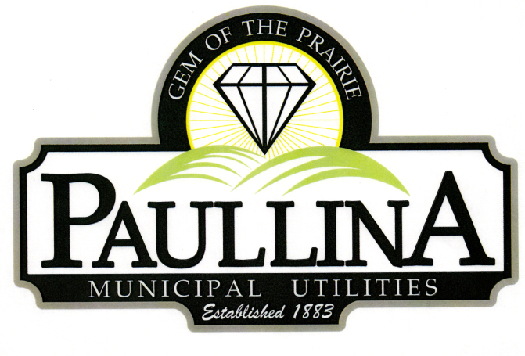

City of Paullina

FINANCE AND ECONOMIC DEVELOPMENT COMMITTEE MEETING

Friday, April 24th, 2026, at 10:00 am

Location: City Hall Council Chambers, 127 South Main St, Paullina, IA 51046

Discussion Items:

- Review of City properties for sale

Committee Meetings are for discussion and information sharing among the committee,
no decisions are made

REMINDERS: Next Regular Council Meeting 05/04/2026

