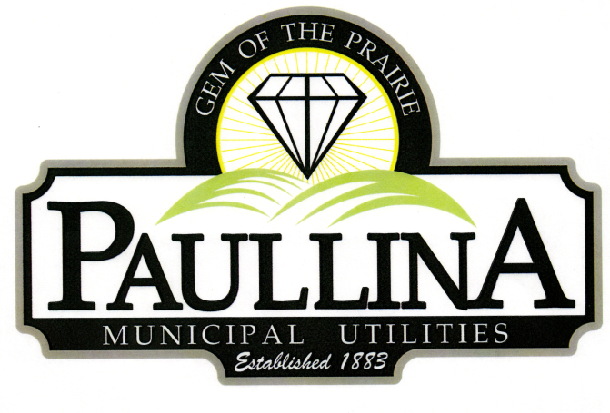

City of Paullina

FINANCE AND ECONOMIC DEVELOPMENT COMMITTEE MEETING

Thursday, April 16th, 2026, at 1:15 pm

Location: City Hall Council Chambers, 127 South Main St, Paullina, IA 51046

Discussion Items:

- Old Iowa State Bank Building
- Lots and Land for Sale
- Explore Housing Development

Committee Meetings are for discussion and information sharing among the committee,
no decisions are made

REMINDERS: Next Regular Council Meeting 04/20/2026

