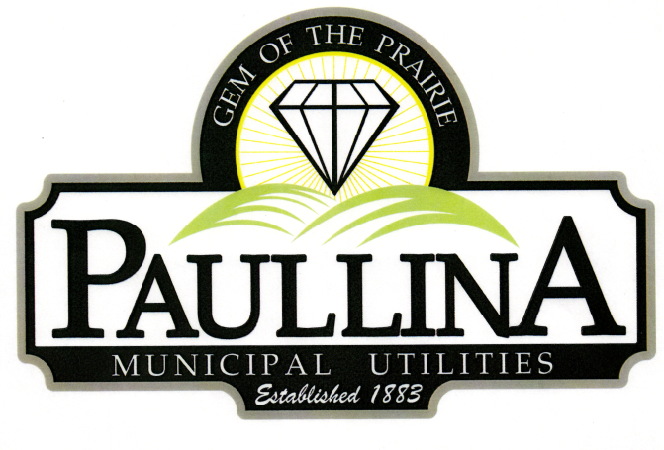

City of Paullina

TENTATIVE REGULAR CITY COUNCIL MEETING AGENDA

Monday, March 16th, 2026, at 5:30pm

Location: City Hall Council Chambers, 127 South Main St, Paullina, IA 51046

- Call to order - Roll Call - Pledge of Allegiance
- Approval of agenda
- Public Forum* for items on and off the agenda

- Consent Agenda (All consent items will be enacted by one motion. There will be no separate discussion of these items unless a request is made prior to the time Council votes on the motion.)
  - Minutes:
    - Approve minutes from 03-02-2026 Regular City Council Meeting
  - Financials:
    - Approve Claims/Revenues
    - Receive February Financials

- Paullina Bike Path
  - Motion to approve funding for mapping and engineering services related to the Paullina Bike Path expansion (not to exceed $2000)

- Part-Time Summer Help
  - Discussion on the need for 1 or 2 part-time summer workers
  - Motion to approve part-time summer help
  - Resolution to establish both the number of part-time employees and their hourly rate

- 412 S Maple St
  - Motion to approve the required repairs of the property
  - Motion to approve the proposed timeline for completing the repairs
  - Motion to approve advertising the property for sale, including outlining any requirements

- FY-27 Budget
  - Schedule a workshop for FY-27 budget review
  - Resolution No. 2026-XX to set a date for Public Hearing on proposed budget for FY-27 (April 6th)

- Police Dept
  - Discuss the current condition of police department vehicles

- Reports
  - Superintendent of Utilities and City Clerk Reports
  - Mayor and City Council Comments
  - Committee Reports
  - Departments – Police/Fire/Ambulance/Library/Airport

- Adjourn
REMINDERS: Proposed Property Tax Levy Public Hearing Monday, March 23rd, at 5:30 pm
Next City Council meeting April 6th, 2026 at 5:30 pm

*Public Forum is the City Council’s opportunity to hear comments from City residents at the beginning of the Regular City Council Meeting for items both on and off the agenda, except for “public hearing” items. During Public Forum, the City Council receives comments and refrains from speaking. The Mayor may ask the City Clerk or a Council Member to follow up. The number of speakers will not usually be limited at the public forum; total length of the forum is desired to not exceed fifteen (15) minutes, and may be lengthened at the discretion of the Mayor and Council. Anyone who wants to speak during Public Forum should do the following:
1. Raise your hand to be recognized by the Mayor and then stand and state your name and address. If you have handouts, please give them to the City Clerk before the meeting.
2. Be concise and limit comments to five (5) minutes. You may not save your time for later or yield the remainder of your time to someone else. After speaking, please be seated.
3. If you are addressing a matter on the agenda, state the agenda item you are speaking about and if you are speaking on more than one agenda item, arrange your comments in chronological order.
4. Try not to duplicate information that has already been presented.
5. Direct comments to the entire Council and not to an individual. Questions and issues raised during this time will generally not be answered during this time.
6. Maintain a courteous and respectful manner.
7. If you are the presenter on an item which has been formally placed on the Council agenda, this public forum process does not apply, although you are asked to be succinct in your presentation.
8. Iowa law requires certain matters to have public hearings, which have their own comment periods. Comments pertaining to a public hearing item should be saved for that item, and the five-minute comment period will also apply for public hearings.
Thank you to everyone in the audience for attending this important business meeting.

