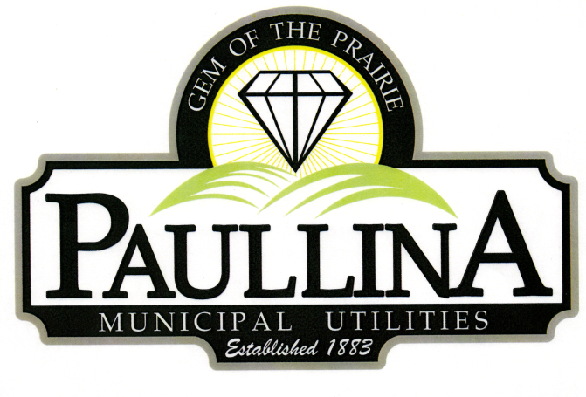

City of Paullina
LEGISLATIVE WORKSHOP

Friday, March 20th, 2026, at 12:30 pm
Location: City Hall Council Chambers, 127 South Main St, Paullina, IA 51046

The City of Paullina will host a Legislative Workshop on Friday, March 20th, at 12:30

PM in the Laue Room. Iowa Senator Lynn Evans will be in attendance to address

questions and engage with attendees regarding their concerns and ideas.

REMINDER: Proposed Property Tax levy Public Hearing is scheduled for Monday, March 23rd at 5:30 pm

