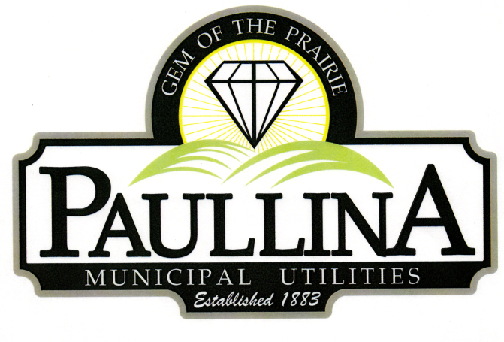

City of Paullina

FINANCE AND ECONOMIC DEVELOPMENT

Monday, March 2nd, 2026, at 4:30 pm

Location: City Hall Council Chambers, 127 South Main St, Paullina, IA 51046

Discussion Items:

- Sale of Property Located at 105 N Main St
- Buyers-Proposals
- Selling Process
- Inspection
- Asbestos Abatement
- Abstract
- Closed Session
- Available Funds
- Sale Price

Committee Meetings are for discussion and information sharing among the committee,
no decisions are made

REMINDERS: Next Council Meeting 3-2-2026

