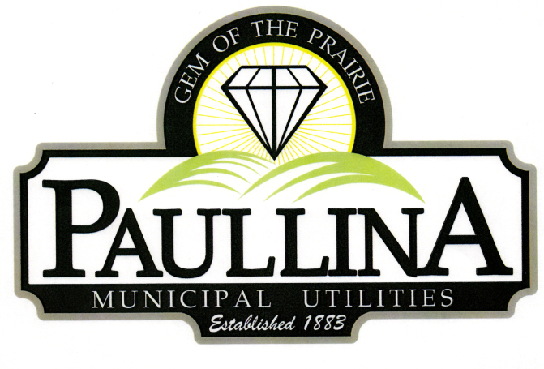

City of Paullina
CITY COUNCIL WORKSHOP AGENDA

Monday, January 26, 2026, at 5:30 pm
Location: City Hall Council Chambers, 127 South Main St, Paullina, IA 51046

- Call to order

- Approval of agenda

- Budget discussion

- Adjourn

Workshops are for discussion and information sharing among the council, no decisions will be made.

REMINDERS: Next regular meeting: Monday, February 2nd, 2026, at 5:30 p.m.

