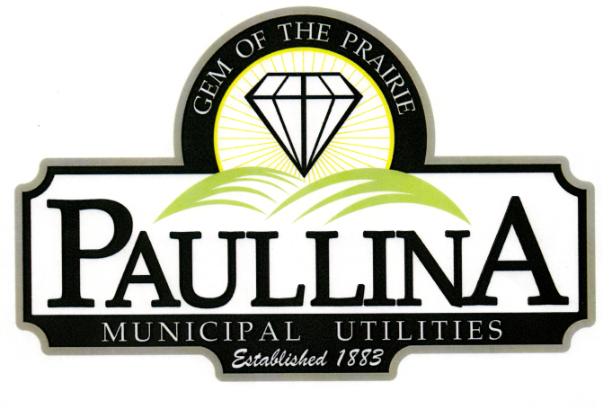

# **City of Paullina**

# **TENTATIVE REGULAR CITY COUNCIL MEETING AGENDA**

# **Monday, September 15th, 2025, at 5:30pm**

**Location: City Hall Council Chambers, 127 South Main St, Paullina, IA 51046**

**Watch livestream: Facebook.com/cityofpaullina**

1. **Call to order - Roll Call - Pledge of Allegiance**
2. **Approval of agenda**
3. **Public Forum* for items on and off the agenda**
4. **City Announcements**
   1. Elections-Nov 4th, 2025 - first day to file papers with City Clerk is 8-25 & the last day to file is 9-18-2025 by 5:00 pm
   2. Fall citywide clean-up is Monday October 6th. Items may be placed on the curb starting Friday, October 3rd. Per our new contract with Town and Country, household piles are limited to approximately a 4X4 pile or the equivalent of one pick-up truck bed.

1. **Consent Agenda** (All consent items will be enacted by one motion. There will be no separate discussion of these items unless a request is made prior to the time Council votes on the motion.)
   1. **Minutes:**
      1. Approve minutes from 09/02/2025 regular City Council Meeting
   2. **Financials:** 
      1. Approve Claims
      2. Approve July Financials
2. **South O’Brien Schools**
   1. Motion to approve Resolution approving street closures for the Homecoming Parade
3. **FY-27 Budget**
   1. Schedule FY-27 Budget Workshops
      1. Weeks of December 22nd, January 11th and 25th.
4. **Required power outage**
   1. There will be a power outage on September 28th from 2pm to 7pm. This outage is required by our new substation contractor to complete substation upgrades.
5. **Reports**
   1. Superintendent of Utilities and City Clerk Reports
   2. Mayor and City Council Comments
   3. Committee Reports
   4. Departments – Police/Fire/Ambulance/Library/Airport
6. **Adjourn**

***REMINDERS:*** *Next City Council Meeting October 6th , 2025 at 5:30 pm*

\***Public Forum** is the City Council’s opportunity to hear comments from City residents at the beginning of the Regular City Council Meeting for items both on and off the agenda, except for “public hearing” items. During Public Forum, the City Council receives comments and refrains from speaking. The Mayor may ask the City Clerk or a Council Member to follow up. The number of speakers will not usually be limited at the public forum; total length of the forum is desired to not exceed fifteen (15) minutes, and may be lengthened at the discretion of the Mayor and Council. Anyone who wants to speak during Public Forum should do the following:

1. Raise your hand to be recognized by the Mayor and then stand and state your name and address. If you have handouts, please give them to the City Clerk before the meeting.

2. Be concise and limit comments to five (5) minutes. You may not save your time for later or yield the remainder of your time to someone else. After speaking, please be seated.

3. If you are addressing a matter on the agenda, state the agenda item you are speaking about and if you are speaking on more than one agenda item, arrange your comments in chronological order.

4. Try not to duplicate information that has already been presented.

5. Direct comments to the entire Council and not to an individual. Questions and issues raised during this time will generally not be answered during this time.

6. Maintain a courteous and respectful manner.

7. If you are the presenter on an item which has been formally placed on the Council agenda, this public forum process does not apply, although you are asked to be succinct in your presentation.

8. Iowa law requires certain matters to have public hearings, which have their own comment periods. Comments pertaining to a public hearing item should be saved for that item, and the five-minute comment period will also apply for public hearings.

Thank you to everyone in the audience for attending this important business meeting.