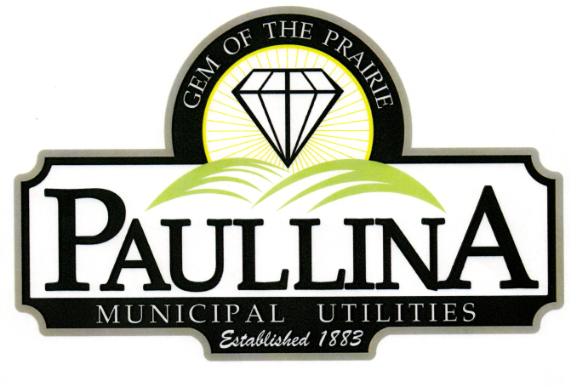**=**

# **City of Paullina**

# **TENTATIVE REGULAR CITY COUNCIL MEETING AGENDA**

# **Monday, August 18th, 2025, at 5:30pm**

**Location: City Hall Council Chambers, 127 South Main St, Paullina, IA 51046**

**Watch livestream: Facebook.com/cityofpaullina**

1. **Call to order - Roll Call - Pledge of Allegiance**
2. **Approval of agenda**
3. **Public Forum* for items on and off the agenda**
4. **City Announcements**
   1. Elections Nov. 4th- 2 Council position and Mayor. First day to file is 8-25. Final day is 9-18 by 5pm. Paperwork is available at City Hall
   2. Police Chief and Lineman Position open
   3. No mowing-discharging in street and sidewalk
   4. Tree and branch clean-up

1. **Consent Agenda** (All consent items will be enacted by one motion. There will be no separate discussion of these items unless a request is made prior to the time Council votes on the motion.)
   1. **Minutes:**
      1. Approve minutes from 08/04/2025
   2. **Financials:** 
      1. Approve Claims
2. **Council Member**
   1. Oath of Office - Newly appointed Council Member John Funkhouser to fill term vacancy ending 12/31/2025
3. **Fall Festival**
   1. A member of the Chamber will be present to share information on Fall Festival
4. **Josh Biery**
   1. Josh passed his sewer test
   2. Consider motion to approve Resolution authorizing .50 to $1 raise for Josh Biery
5. **Police Department**
   1. Update on status
   2. Motion to approve interim policing plan
6. **Reports**
   1. Superintendent of Utilities and City Clerk Reports
   2. Mayor and City Council Comments
   3. Committee Reports
   4. Departments – Police/Fire/Ambulance/Library/Airport
7. **Adjourn**
8. **Police Chief**
   1. Recognition for Police Chief Nathan Bremer’s retirement

***REMINDERS:*** *Next City Council Meeting September 2nd, 2025 at 5:30 pm*

\***Public Forum** is the City Council’s opportunity to hear comments from City residents at the beginning of the Regular City Council Meeting for items both on and off the agenda, except for “public hearing” items. During Public Forum, the City Council receives comments and refrains from speaking. The Mayor may ask the City Clerk or a Council Member to follow up. The number of speakers will not usually be limited at the public forum; total length of the forum is desired to not exceed fifteen (15) minutes, and may be lengthened at the discretion of the Mayor and Council. Anyone who wants to speak during Public Forum should do the following:

1. Raise your hand to be recognized by the Mayor and then stand and state your name and address. If you have handouts, please give them to the City Clerk before the meeting.

2. Be concise and limit comments to five (5) minutes. You may not save your time for later or yield the remainder of your time to someone else. After speaking, please be seated.

3. If you are addressing a matter on the agenda, state the agenda item you are speaking about and if you are speaking on more than one agenda item, arrange your comments in chronological order.

4. Try not to duplicate information that has already been presented.

5. Direct comments to the entire Council and not to an individual. Questions and issues raised during this time will generally not be answered during this time.

6. Maintain a courteous and respectful manner.

7. If you are the presenter on an item which has been formally placed on the Council agenda, this public forum process does not apply, although you are asked to be succinct in your presentation.

8. Iowa law requires certain matters to have public hearings, which have their own comment periods. Comments pertaining to a public hearing item should be saved for that item, and the five-minute comment period will also apply for public hearings.

Thank you to everyone in the audience for attending this important business meeting.