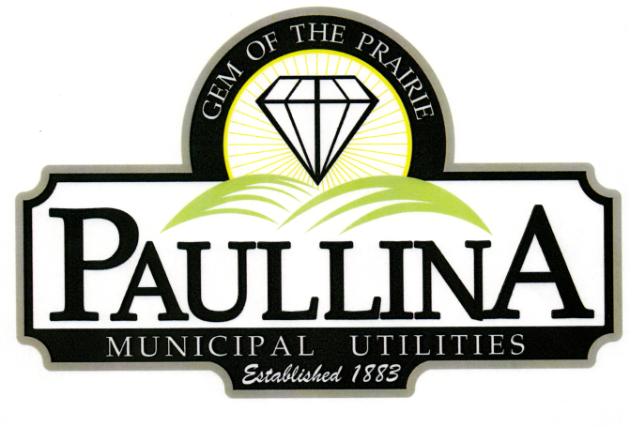

# **City of Paullina**

**CITY COUNCIL WORKSHOP AGENDA**

# **Wednesday July 30th, 2025, at 6:00 pm**

**Location: City Hall Council Chambers, 127 South Main St, Paullina, IA 51046**

1. **Call to order, Roll Call**
2. **Approval of agenda**
3. **Review and discuss Police Department**
4. **Review and discuss City Properties**
5. **Adjourn**

**Workshops are for discussion and information sharing among the council, no decisions will be made.**

***REMINDERS:*** *Next regular meeting: Monday, August 4th, 2025 at 5:30pm*

*Board of Adjustments Public Hearing Tuesday August 5th, 2025 at 7:00pm*