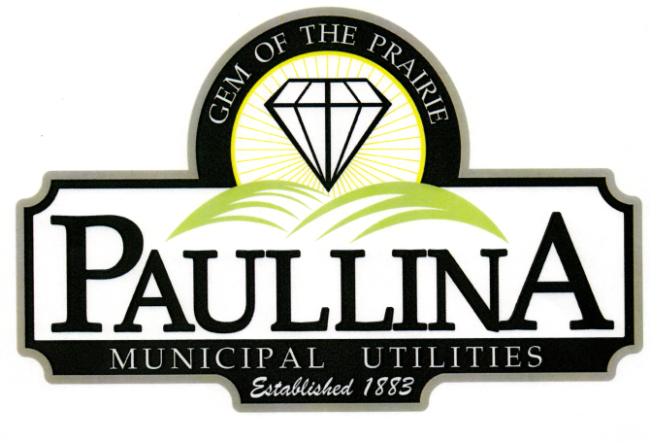

# **City of Paullina**

# **TENTATIVE SPECIAL CITY COUNCIL MEETING AGENDA**

# **Wednesday June 25th, 2025, at 6:00**

**Location: City Hall Council Chambers, 127 South Main St, Paullina, IA 51046**

**Watch livestream: Facebook.com/cityofpaullina**

1. **Call to order - Roll Call - Pledge of Allegiance**
2. **Approval of agenda**
3. **Fire Department**
   1. Accept the resignation of Fire Chief Ryan Harper
   2. Approve election of Brytton Kelleher as Fire Chief
      1. Swearing in of Brytton Kelleher as Fire Chief
4. **Deputy Clerk**
   1. The Employee Committee will review with candidates for Deputy Clerk and recommendations
      1. Motion to make offer to recommended Deputy Clerk Candidate
5. **FY-26 Wages**
   1. Motion to approve Resolution for FY-26 Wages
6. **Mosquito Control**
   1. Clerk Wilson will review with Council the City of Hartley’s charge for providing mosquito control
   2. Motion to approve having Hartley spray for mosquitos
7. **Adjourn**

***REMINDERS:*** *Next City Council Meeting July 7th , 2025 at 5:30 pm*

\***Public Forum** is the City Council’s opportunity to hear comments from City residents at the beginning of the Regular City Council Meeting for items both on and off the agenda, except for “public hearing” items. During Public Forum, the City Council receives comments and refrains from speaking. The Mayor may ask the City Clerk or a Council Member to follow up. The number of speakers will not usually be limited at the public forum; total length of the forum is desired to not exceed fifteen (15) minutes, and may be lengthened at the discretion of the Mayor and Council. Anyone who wants to speak during Public Forum should do the following:

1. Raise your hand to be recognized by the Mayor and then stand and state your name and address. If you have handouts, please give them to the City Clerk before the meeting.

2. Be concise and limit comments to five (5) minutes. You may not save your time for later or yield the remainder of your time to someone else. After speaking, please be seated.

3. If you are addressing a matter on the agenda, state the agenda item you are speaking about and if you are speaking on more than one agenda item, arrange your comments in chronological order.

4. Try not to duplicate information that has already been presented.

5. Direct comments to the entire Council and not to an individual. Questions and issues raised during this time will generally not be answered during this time.

6. Maintain a courteous and respectful manner.

7. If you are the presenter on an item which has been formally placed on the Council agenda, this public forum process does not apply, although you are asked to be succinct in your presentation.

8. Iowa law requires certain matters to have public hearings, which have their own comment periods. Comments pertaining to a public hearing item should be saved for that item, and the five-minute comment period will also apply for public hearings.

Thank you to everyone in the audience for attending this important business meeting.