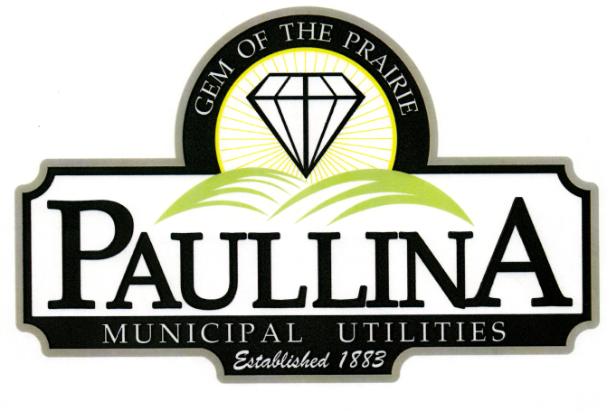

# **City of Paullina**

# **TENTATIVE REGULAR CITY COUNCIL MEETING AGENDA**

# **Monday, May 19th, 2025, at 5:30**

**Location: City Hall Council Chambers, 127 South Main St, Paullina, IA 51046**

**Watch livestream: Facebook.com/cityofpaullina**

1. **Call to order - Roll Call - Pledge of Allegiance**
2. **Approval of agenda**
3. **Public Forum* for items on and off the agenda**
4. **City Announcements**
5. **Consent Agenda** (All consent items will be enacted by one motion. There will be no separate discussion of these items unless a request is made prior to the time Council votes on the motion.)
   1. **Minutes:**
      1. Approve minutes from 05/05/2025 Regular City Council Meeting
   2. **Financials:** 
      1. Approve claims
      2. Receive April Financials to be approved at the June 2nd Council Meeting
   3. **Tobacco Retail Permit**
      1. Approve Tobacco Retail Permit for Casey’s # 3730
6. **Billing Software**
   1. Review of Tyler Tech Software Program
   2. Consider approval of Tyler Tech Contract
7. **Ambulance**
   1. Review Ambulance By-Laws and Constitution
   2. Motion to approve Ambulance By-Laws
   3. Motion to approve Ambulance Constitution
8. **Little League**
   1. Discuss modifications of the Little League dugouts
   2. Motion to approve modifications of the Little League dugouts
9. **Mosquito Control**
   1. Superintendent of Utilities will inform the Council of a recent option
   2. Consider moving forward with mosquito control option
10. **Street Repairs**
    1. Discuss priority street repair list
11. **Personnel** 
    1. Review of the Deputy Clerk’s work performance-Note: this item could include a closed session under Iowa Code 21.5(1) (i)
    2. Consider actions/decisions needed regarding the Deputy Clerk’s performance
12. **Reports**
    1. Superintendent of Utilities and City Clerk Reports
    2. Mayor and City Council Comments
    3. Committee Reports
    4. Departments – Police/Fire/Ambulance/Library/Airport
13. **Adjourn**

***REMINDERS:*** *Next City Council Meeting June 2nd , 2025 at 5:30 pm*

\***Public Forum** is the City Council’s opportunity to hear comments from City residents at the beginning of the Regular City Council Meeting for items both on and off the agenda, except for “public hearing” items. During Public Forum, the City Council receives comments and refrains from speaking. The Mayor may ask the City Clerk or a Council Member to follow up. The number of speakers will not usually be limited at the public forum; total length of the forum is desired to not exceed fifteen (15) minutes, and may be lengthened at the discretion of the Mayor and Council. Anyone who wants to speak during Public Forum should do the following:

1. Raise your hand to be recognized by the Mayor and then stand and state your name and address. If you have handouts, please give them to the City Clerk before the meeting.

2. Be concise and limit comments to five (5) minutes. You may not save your time for later or yield the remainder of your time to someone else. After speaking, please be seated.

3. If you are addressing a matter on the agenda, state the agenda item you are speaking about and if you are speaking on more than one agenda item, arrange your comments in chronological order.

4. Try not to duplicate information that has already been presented.

5. Direct comments to the entire Council and not to an individual. Questions and issues raised during this time will generally not be answered during this time.

6. Maintain a courteous and respectful manner.

7. If you are the presenter on an item which has been formally placed on the Council agenda, this public forum process does not apply, although you are asked to be succinct in your presentation.

8. Iowa law requires certain matters to have public hearings, which have their own comment periods. Comments pertaining to a public hearing item should be saved for that item, and the five-minute comment period will also apply for public hearings.

Thank you to everyone in the audience for attending this important business meeting.